St. Matthew’s
Primary School


Standards & Quality Report
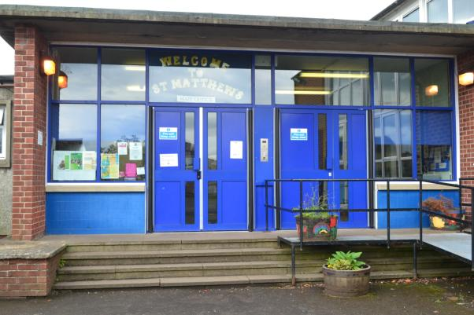

Context of the School

St. Matthew’s PS is a denominational school situated in Bishopbriggs. This session there are 340 children divided into 14 classes. The management structure consists of a Head Teacher, two Depute Head Teachers one of whom is recently appointed in an Acting Depute Head Teacher role and one newly appointed Principal Teacher. We have 2 Newly Qualified Teachers. The school has 3 instrumental teachers, 1 music teacher, 3 Classroom Assistants, 3 Support for Learning Assistants and 3 members in our office administration team, 1 of whom is a newly appointed administrative assistant. We also have a School Janitor who leads a team of three cleaners, a catering supervisor and three catering staff.

Parents are highly committed to supporting the school community. The Parent Council work cooperatively with the school and meet regularly. There is also a very active Parent Teacher Association (PTA) which organises social and fundraising events throughout the year. Parent helpers are welcome and frequently assist with classroom activities and school outings. There are a large number of extra-curricular activities including football, cross country running, guitar, skipping, basketball, netball, dance enjoy-a-ball, football and gaelic football.. Pupil participation is encouraged through the 7 pupil committees and a Junior Management Team. All children are members of a committee within the school.

Children enter in Primary 1 from a wide range of nurseries across and beyond the authority from both Local Authority and private and partnership nurseries. At the end of P7 most pupils transfer to Turnbull High School. Clear and validated transition arrangements exist into St. Matthew’s PS from nurseries and from St. Matthew’s PS to Turnbull High School. We benefit from very strong links with our cluster schools, St. Helen’s PS and St. Andrew’s PS and other local schools. The School Improvement Plan is created in partnership with all staff, pupil representatives and with Cluster Colleagues. The SIP is shared with the Parent Council and additions on their suggestions are implemented.
Calendar in place created

We have a Quality Assurance/Self-Evaluation for Self Improvement Calendar created in consultation with staff and taking into account National and Local requirements as well as measures recognised within the school through self-evaluation.

The Senior Management Team, with advice from EDC have a collegiate approach to improvement and encourage all staff to be involved in moving the school forward. Staff are actively involved in all Self-Evaluation and in developing the actions recognised.

This session staff have worked collegiately to continue to improve attainment in literacy and numeracy and ensure the implementation of Health and Wellbeing within a Catholic School Setting. Staff have also worked on monitoring achievement and are committed to ensuring Equity for all.

This session we have focussed on developing the nurturing principles within the school and classroom and ensuring we provide the very best learning environment for the pupils in our care. Through close monitoring and tracking and professional dialogue to work hard to provide learning experiences matched to the needs to learners. Staff are beginning to provide more challenging activities for our more able pupils and put in place measures to alleviate barriers to learning.

SMT work closely with staff to provide support within the classroom and also to provide appropriate training and resources to ensure that learners’ needs are met.

A well planned PRD programme ensures that all staff are supported to provide the requirements of the SIP and National and Local requirements. Staff are beginning to evaluate their own practice through small scale professional enquiries within their class and share their good practice with others. Staff are beginning to take more pro active steps to develop their own professional learning.

Within the school leadership of all stands at the forefront. All staff lead a committee and many take on other roles and responsibilities to ensure the development of the school. This area should continue to be improved with staff taking the initiative to lead areas within the school and actively seek ways to lead the school to excellence.

The collegiate and professional attitude of staff ensures that St. Matthew’s PS continues to meet the demands of CfE and HGIOS4. Staff are becoming more willing and confident to offer ideas and positive steps for the future.

The SMT feel fully supported by staff and the positive working relationships in the school in recent years and months have had very positive outcomes.

The SMT feel the school is well placed to move forward with the current staff in their present roles.

Our NIF results are below. We continue to attain well across the school and have highlighted dips in attainment at the P1 stage which will feed into next session’s plans.

CfE Levels | Reading | Writing | L&T | Numeracy
P1 (Early)
Secure | 81% | 81% | 81% | 81%
Not yet secure | 19% | 19% | 19% | 19%
Primary 4 (first)
Secure | 84% | 84% | 89% | 93%
Not yet secure | 16% | 16% | 11% | 7%
Primary 7 (second)
Secure | 98% | 93% | 98% | 93%
Not yet secure | 2% | 7% | 2% | 7%

School priority 1: Attainment & Achievement
NIF Priority: Improvement in attainment, particularly in literacy and numeracy  NIF Driver:  Assessment of children’s progress | HGIOS 4 QIs  2.3 Learning, teaching  and assessment  2.6 Transitions  3.2 Raising attainment  and achievement
Progress and impact:
Almost all children have achieved appropriate levels in literacy and numeracy in P1, P4 and P7. A number of children have exceeded the appropriate levels. By monitoring and tracking children’s progress, gaps in children’s learning have been identified and appropriate supports put in place in order that attainment is raised.

Next Steps:
Formalise procedures and develop an overview to engage families in children’s learning to help raise attainment and reduce the equity gap.
Fully implement steps to tackle vocabulary gaps in early and first level.

School priority 2: GIRFEC
NIF Priority:  Closing the attainment gap between the most and least disadvantaged children  NIF Driver:  Teacher Professionalism | HGIOS 4 QIs  2.4 Personalised Support  3.2 Raising attainment and achievement
Progress and impact:
Almost all staff are providing effective universal support through differentiated lessons and activities ensuring appropriate pace and challenge for all learners. By monitoring and tracking, learners’ needs are quickly identified and appropriate, proportionate and timely supports are put in place. Most staff are using the 4 contexts of differentiation to adapt and remove barriers to learning. The school works closely with partners to ensure inclusion for all.

Next Steps:
Embed the 4 contexts of differentiation across the school.
Children to develop confidence in setting their own learning targets.
Provide quality targeted support for more able children
Look at innovative approaches to enhance established good practice.

School priority 3: Cluster Moderation – Numeracy – Fractions, Decimals, Percentages
NIF Priority:  Improvement in attainment, particularly in literacy and numeracy  NIF Driver:  Performance information | HGIOS 4 QIs  2.3 Learning, Teaching and Assessment
Progress and impact:
All staff have worked with teachers across the cluster. Examples of secure learner at Early, First, Second and Third were shared. Examples of moderated work was shared with all staff. A showcase of moderated examples was organised and all teaching staff attended. Teachers involved have reported feeling more confident with the process and this can now be applied to other curricular areas.

Next Steps:
Transfer this knowledge to other areas of the curriculum and involve all staff. Work with benchmarks in other curricular areas through moderation and planning processes. Continue to work with cluster colleagues to ascertain moderated levels of a secure learner.

Key priorities for improvement planning 2017-18

Attainment: Play- Extend learning through play
Formalise all programmes of study

Assessment- Profiling as part of children’s work
Action Planning for learners- new paperwork and embedding this

HWB-
Rights Respecting Schools
Leadership of children throughout the school

What is our capacity for continuous improvement?

NIF quality indicators

Quality indicator | School self-evaluation | Inspection / Authority evaluation  ( If available)
1.3 Leadership of change | 4
2.3 Learning, teaching and assessment | 4
3.1 Ensuring wellbeing, equity and inclusion | 4
3.2 Raising attainment and achievement | 4

